

**SHAID SMARAK COLLEGE**

Kirtipur, Kathmandu

*Lab no: 7 of Digital logics*

**Submitted by :-**

1st semester

Amir Maharjan

**Submitted to :-**

Himal Raj Gental

**LAB 6: Demultiplexer**

**Objective:**

* To know about demultiplexer and how to implement it.

**Discussion:**

The function of the Demultiplexer is to switch one common data input line to any one of the 4 output data lines A to D. As with the multiplexer the individual solid-state switches are selected by the binary input address code on the output select pins “a” and “b” as shown.

**Demultiplexer:**

A demultiplexer (or demux) is a circuit that receives information on a single line and transmits this information on one of 2n possible output lines. The selection of a specific output line is controlled by the bit value of n selection lines. A decoder with an enable input can function as a demultiplexer. Here enable input and input variable for decoder is taken as data input line and selection line for the demultiplexer.

**1-to-4 De-multiplexer:**

|  |  |  |  |  |  |
| --- | --- | --- | --- | --- | --- |
| **Selection Inputs** | | **Outputs** | | | |
| **S1** | **S0** | **Y3** | **Y2** | **Y1** | **Y0** |
| 0 | 0 | 0 | 0 | 0 | 1 |
| 0 | 1 | 0 | 0 | 1 | 0 |
| 1 | 0 | 0 | 1 | 0 | 0 |
| 1 | 1 | 1 | 1 | 0 | 0 |

The Boolean function for this 1-to-4 demultiplexer (demux) above outputs A to D and data select lines a, b is given as:

**Y3 =­s1s01**

**Y2 =s1s0’1**

**Y1 = s1’s01**

**Y0 = s1’s0’1**

The function of the demultiplexer (demux) is to switch one common data input line to any one of the 4-output data line A to D in our example above. As with the multiplexer the individual solid-state switches are selected by the binary input address code on the output select pins “a” and “b” as shown.

As with the previous MUX circuit, adding more address line inputs, it is possible to switch more outputs giving a 1-to-2n data line outputs. Some standard DEMUX has an additional enable output which prevents the input form being passed to the selected output. The implementation of the Boolean expression above using individual logic gates would require the use of six individual gates consisting of AND and NOT gates as given below:

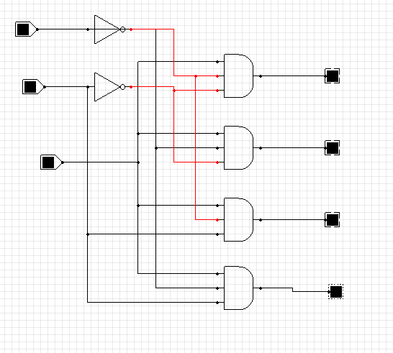

*Fig: logic diagram of 1-to-4 demultiplexer*

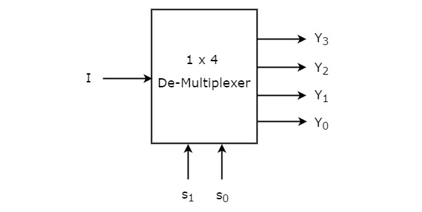

As with MUX, we can also use the DEMUX to digitally control the gain of an operational amplifier as shown.